



Example Student 1

Example Student 2

Example Student 3

Example Student 4



Online Vet Clinic Appointment System

(OVCAS)

Technical Manual

A technical manual is a well-defined document that explains the means for operating, maintaining, supporting or installing a machine, process, system, or piece of equipment.

# About system

# About Manual

The manual is a two-part manual, one for the technical manual and the other one as the user manual. The technical manual is a guidebook that tells you on how toinstall the web application. On the other hand, the user manual guides the users on how to use the whole system. Included in this technical manual are the screenshots and a step-by-step to install the web application then other third-party applications.

# Requirements

* Source Code
* XAMPP v5.5.19 click here to download: <https://sourceforge.net/projects/xampp/files/XAMPP%20Windows/5.5.19/>
* Visual Studio Code
  + Install Extension ( FTP Simple )
* An Account on InfinityFree: Free Web Hosting

Contents

About system i

About Manual ii

Requirements iii

Downloading Source Code and Database 1

Installation Guide for XAMPP and Visual Studio Code 2

Running the web app in localhost 3

Deploying web app to InfinityFree Hositing 8

Configure the Connection of source code 11

References 12

# Downloading Source Code and Database

Open your browser then copy and paste this link : <https://drive.google.com/drive/folders/1iqL6M6JLgzMvz3KayJOyJQCr7xmizxoM>

Then you’ll see the file of source code and database

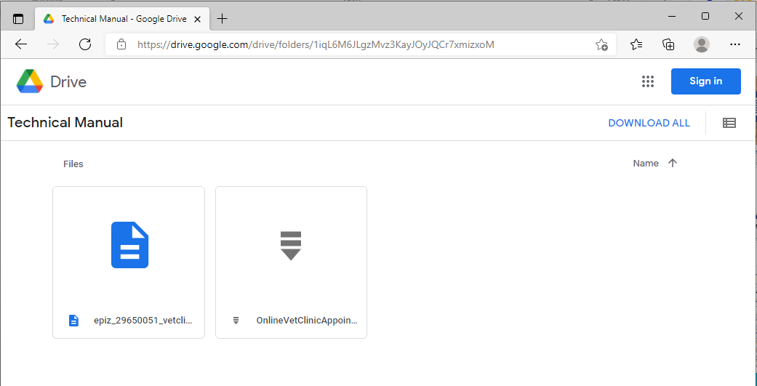

At the top-right of your browser click DOWNLOAD ALL then wait until the file is downloaded.

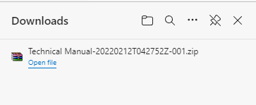

# Installation Guide for XAMPP and Visual Studio Code

* (IONOS, 2019)This is the guide to install XAMPP. Open your browser just copy and paste or click the link to see more details then follow the steps: <https://www.ionos.com/digitalguide/server/tools/xampp-tutorial-create-your-own-local-test-server/>

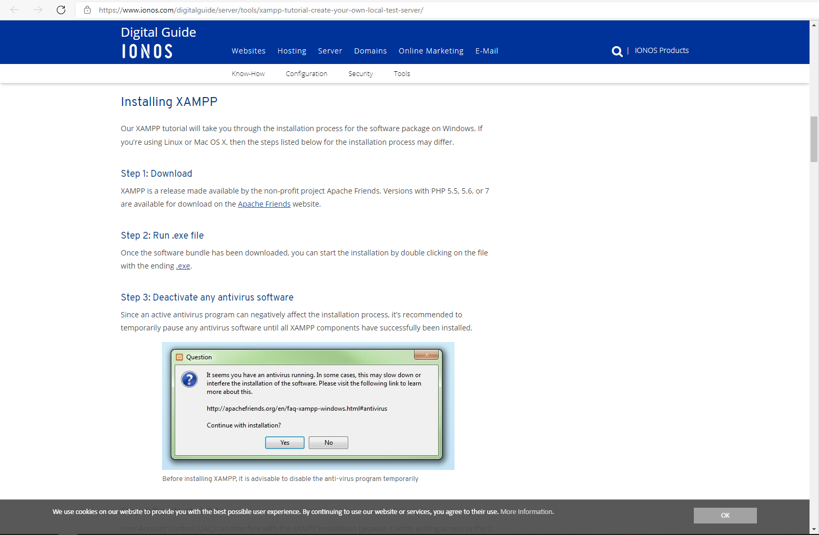

* (Sharma, 2021) And this is the guide on how to install Visual Studio Code. Open your browser, then copy and paste or click the link to see more details: <https://www.toolsqa.com/blogs/install-visual-studio-code/>

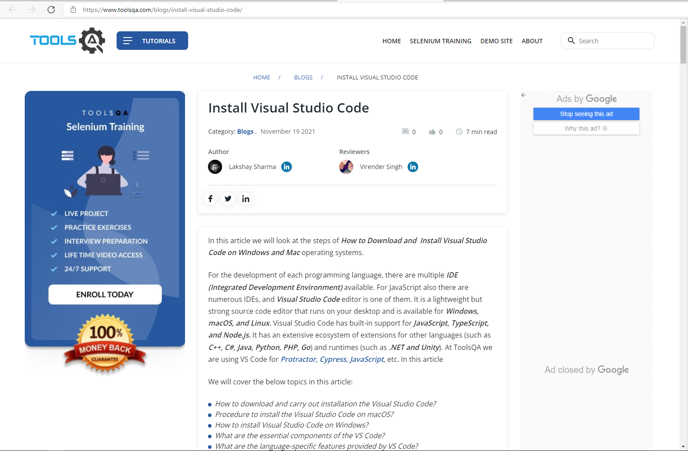

# Running the web app in localhost

**Note:** Follow the steps listed below for the process to extract files, importing database and running the web app in localhost.

**Step 1 – Extracting files**

* Open Downloads folder then unzip the “Technical Manual-20220212T042752Z-001”. To unzip just right click the file then click Extract Here.

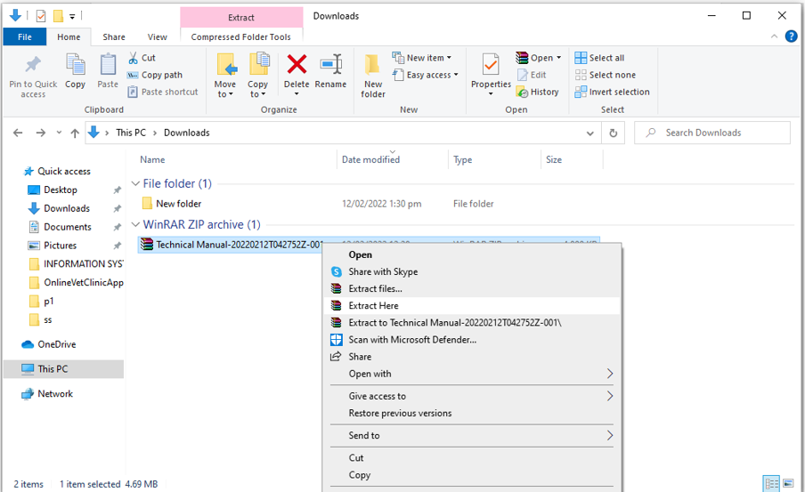

**Step 2 – Open htdocs directory**

* After extracting files, open now the command prompt or (CMD) and type or copy and paste this command: start C:/xampp/htdocs
  + To popup the htdocs directory of XAMPP. It is a folder name used in xampp. In there you can your own user defined folder for storing data. It is basically web server solution package and kind of virtual server.

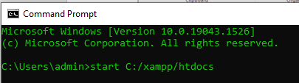

**Step 3 – Deploying source code to the htdocs**

* Copy the source code folder named “OnlineVetClinicAppointment” inside the “Technical Manual” folder that you’ve been extracted before. Then paste it in the htdocs directory.

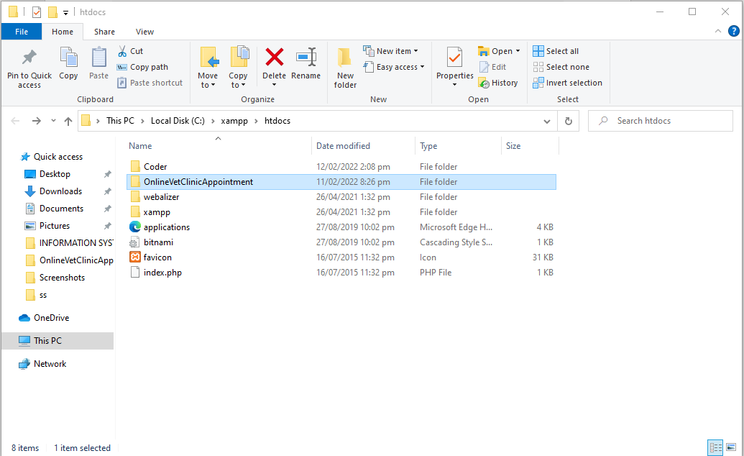

**Step 4 – Open XAMPP Control Panel**

* Search for XAMPP Control Panel then Open. And it will pop up the user interface of XAMPP Control Panel.

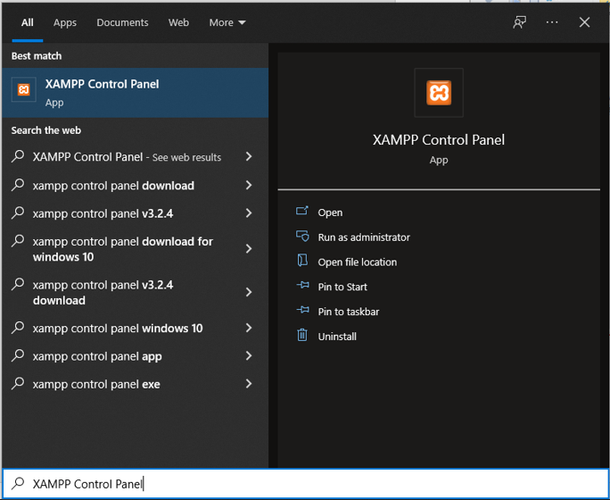

**Step 5 – Running Apache and MySQL**

* If you’ll see start button of Apache and MySQL then click it.

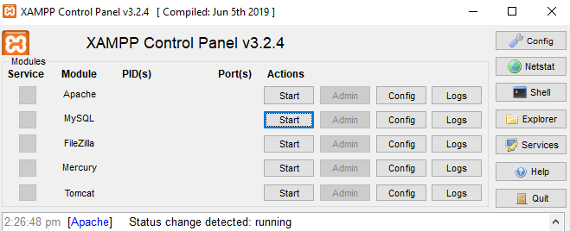

**Step 6 – Opening Phpmyadmin**

* You’ll see in MySQL the admin button is Enable now, then click it to show the phpMyAdmin browser.

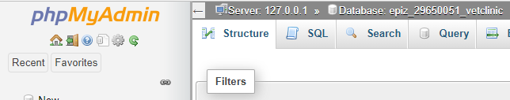

**Step 7 – Creating Database**

* Click New in phpMyAdmin then set the database name to “epiz_29650051_vetclinic” and click “Create” button to create database.

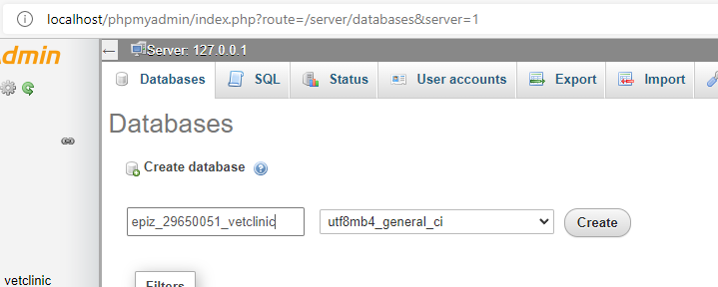

**Step 8 – Importing Database**

* After you creating database, now you can click the “Import” to import database from the “Technical Manual” folder that you’ve been extracted before.

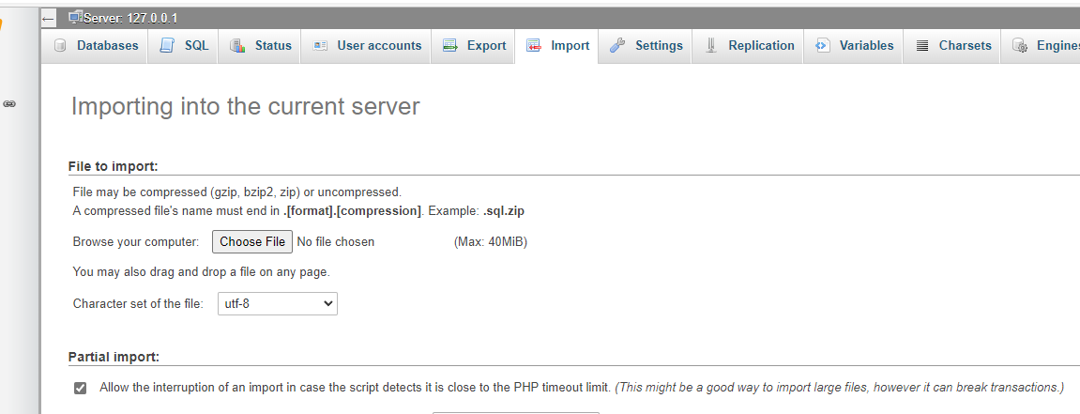

* Then to restore data from “epiz_29650051_vetclinic.sql” to current database server. Click Choose File then open Downloads folder then open the Technical Manual folder then select epiz_29650051_vetclinic.sql click Open and Go.

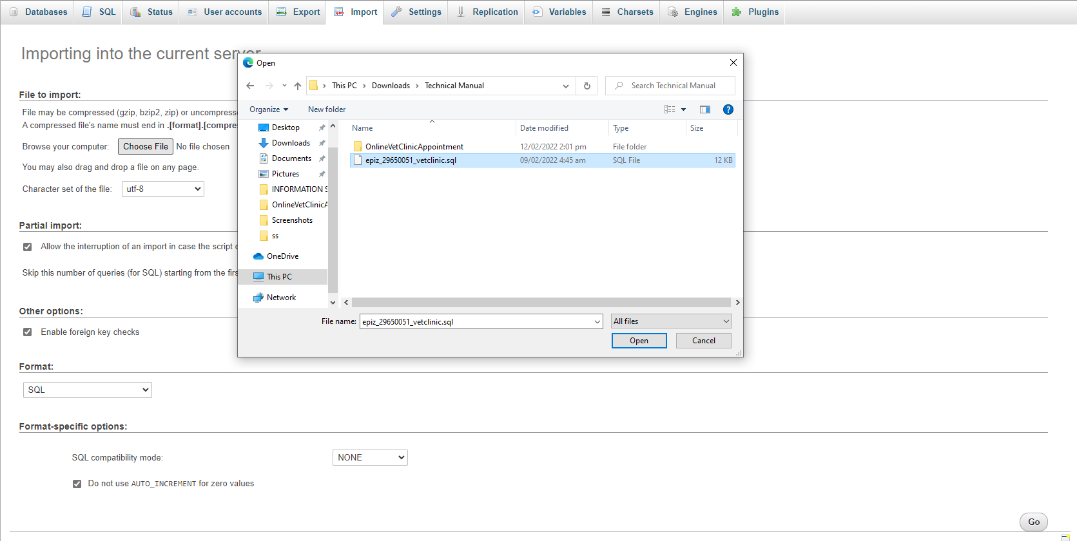

* If the importing is successful, it shows the structure of this database.

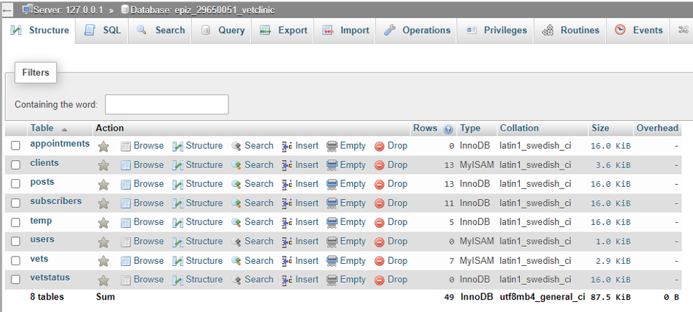

**Step 9 – Running Web App to the localhost**

* Open any browser then type or copy and paste this URL localhost/OnlineVetClinicAppointment/index.php

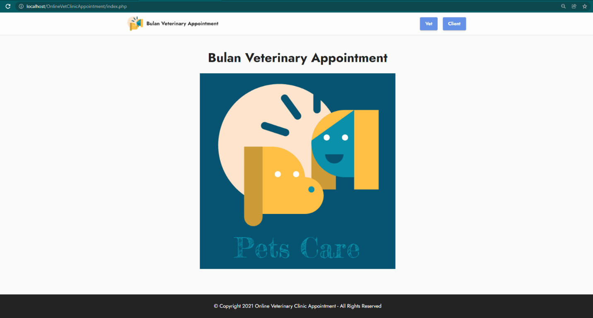

**Note:** If you’ll see this webpage is working. Then you’ve been deployed it successfully. And if it’s not working, you can see in **page 11** on how to configure the code or please contact the programmer to config and debug the error of this code.

# Deploying web app to InfinityFree Hositing

**Note**: Follow the steps listed below for the process to install simple FTP extension in vscode and deployment of the app to the live server.

**Step 1 – Login Account**

* Open InfinityFree portal and login your credential

here: <https://app.infinityfree.net/login>

**Step 2 - Create a Hosting Account**

* After you login click create account and search for available subdomain.

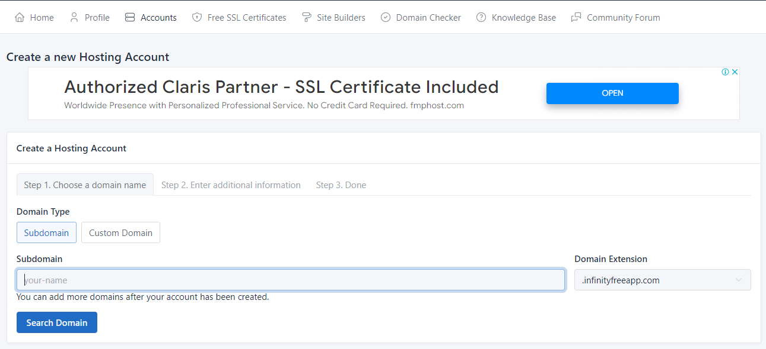

* type password between 8 – 15 characters then click Create Account to be Done.

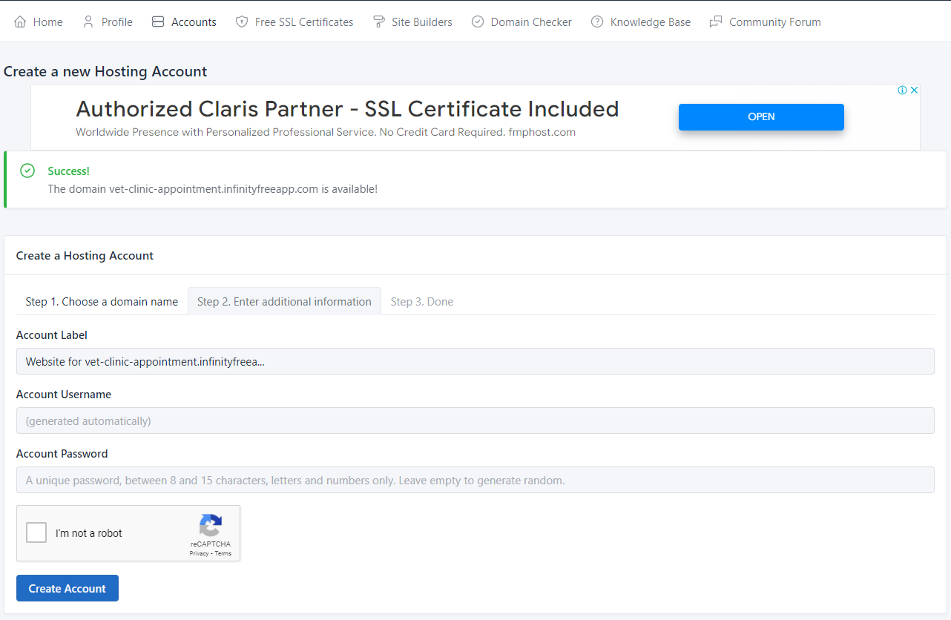

**Step 3 – Manage Accounts**

* Once you’ve done creating a Hosting Account. Click Manage in Account to show FTP Details.
* Then click show/hide FTP Password to see the password authentication.

**Step 4 – FTP-simple Extension on Visual Studio Code**

* To install ftp-simple extension just open visual studio code then press shortcut keys Ctrl + Shift + X and search for ftp-simple then click install.

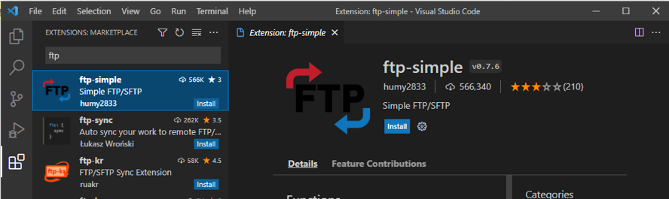

**Step 5 – Setup FTP connection**

* Press **F1** and search for FTP connection then select **ftp-simple: Config – FTP connection setting**.
* It shows the ftp-simple-temp.json file to setup ftp connection to infinityFree.

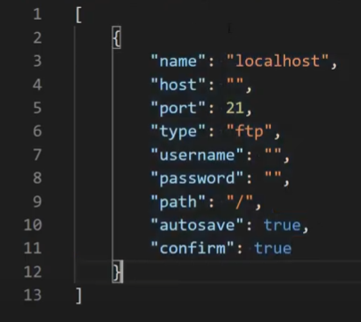

* Just edit/change host, username and password same as to the FTP Details. Then change the name localhost to OVCAS

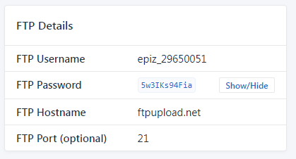

* Then once you setup ftp connection. Open terminal in VSCode under OUTPUT select ftp-simple. Then Press **F1** again and search for **ftp-simple: Remote directory open to workspace** and select OVCAS.
* And its shows you a .Current directory:/ and htdocs TYPE: Directory etc.

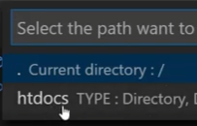

* Then select htdocs.

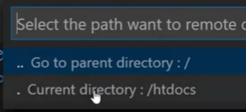

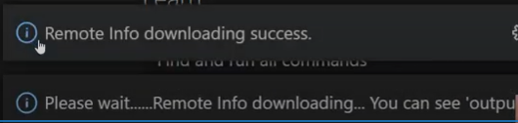

* After success the Remote of subdomain using ftp-simple it’s fully control and you can now deploy/create a project in this subdomain.

# Configure the Connection of source code

**Note:** Open connect.php file from “OnlineVetClinicAppointment” folder on vscode to configure the connection of server.

* Uncomment this if you want to run the connection on live server.

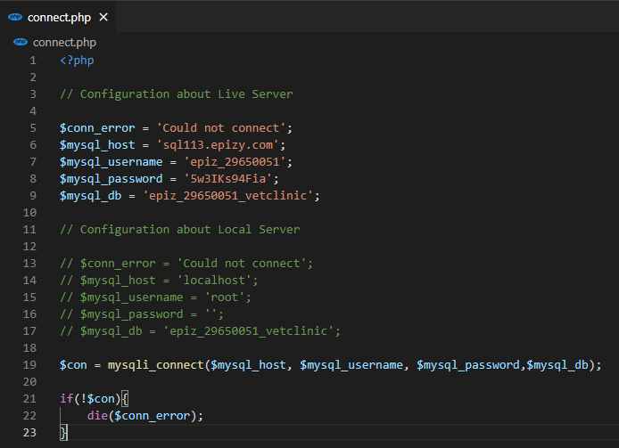

* Uncomment this if you want to run the connection on local server.

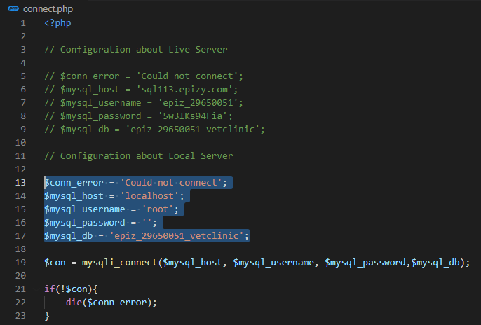

# References

IONOS. (2019, August 29). *XAMPP tutorial: create your own local test server - IONOS*. Retrieved from XAMPP tutorial: installation and first steps: https://www.ionos.com/digitalguide/server/tools/xampp-tutorial-create-your-own-local-test-server/

Sharma, L. (2021, November 19). Retrieved from Install Visual Studio Code: https://www.toolsqa.com/blogs/install-visual-studio-code/